Mr. Matkins’ Wish List 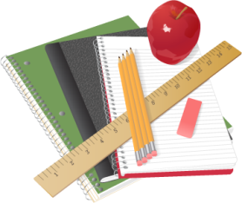

Throughout the year, my classes will participate in activities, labs, assignments, and other things that will aide in their learning. In order for them to be carried out, materials are needed. I have supplied a small list that includes some of the items. I would be more than grateful if I received some of these items at the beginning of the year or throughout. I’m sure some extra credit could be applied to your child for bringing in some items. I would greatly appreciate it!
- Hand sanitizer
- Paper Towels
- Kleenex® Tissues
- Clorox® Disinfecting Wipes
- Pencils
- Erasers
- Colored Pencils
- Highlighters
- Colored Construction Paper (Any size)
- Poster board
- Index Cards
- Ziploc Bags (any size)
- Paper Bags
- Plastic Utensils
- Plastic Cups
- Aluminum Foil
- Tongue Depressors
- Medicine droppers
- Q-Tips
- Baking Soda
- Sugar
- Salt
- Cotton Balls
- Toothpicks
- Pie Tins
- Straws
- Balloons
- Colored Chalk

